PINNACLE HIGH INTERNATIONAL SCHOOL - MALAD

Sub: Tour to Udaipur with Chittaurgarh Fort

Venue : Udaipur with Chittaurgarh Fort

Dates : Friday 7th February, 2020 to Tuesday 11th February, 2020

Accommodation : In decent star category hotels with deluxe rooms on multiple sharing
basis with attached bath & all modern amenities.

Hotel Name : Rishika Clarks Inn Udaipur

Address : NH-8, Opposite EKLINGJI, Udaipur - Nathdwara Main Highway,
Munwas, Udaipur, Rajasthan- 313001

Contact Number : 072320 28333

Meals : Delicious Jain /Veg/ Non Veg buffet meals with a lot of snack hampers,
Cold drinks & chocolates at regular intervals.

Transportation : Mumbai- Udaipur: III AC Train: 19668 UDZ HUMSAFAR EXP: (Friday 7th February,2020)
Departure time- 12.40 PM. Arrival time - 04:55 AM (Nextday)

Udaipur - Mumbai: III AC Train: 19667 MYS HUMSAFAR EXP : (Monday 10th February ,2020)
Departure time- 09.10 PM. Arrival time - 01:05 PM (Nextday)

In and around by Ac luxury deluxe coaches

SIGHTSEEING : Maharana Pratap Smarak, FatehSagar Lake, Sahelion Ki Bari,
Majestic City Palace, Chittaurgarh Fort.

Arrival & Departure Timings and Details:

7th February, 2020: Report at School in PT shirt and comfortable pants at 08.00 am to board the bus for Vasai Station to board the train for Udaipur.

11th February, 2020: Arrive at Vasai Road Station at 01.00 pm & Board the bus for School & reach school by 04.00 pm

Things to Carry: {Please note: Students have to carry a small trolley bag or a Haversacks with proper locking facility and keys to be retained by the student} 04 Pairs of clothes, undergarments, handkerchief, toiletries (towel, soap, tooth brush, tooth paste, shampoo, sun screen lotion), cap, water bottle, floaters or strong sandals, strong shoes and socks, sweater, Mosquito band & stickers, Plastic bags for keeping wet / used clothes.
All students are requested to carry their school Identity Cards for Train Identification

TOUR ORGANISOR – M/S. ADVENTURE EDUCATION TOURS (MUMBAI) PVT. LTD

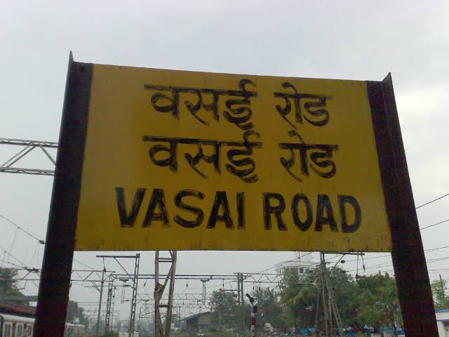
DAY 01 MUMBAI – UDAIPUR : (Friday 7th February, 2020 )

Assemble in School at 08.00 am & board buses for Vasai Road Station to board the train for Udaipur. Lunch & Dinner will be served in train. Overnight in train.

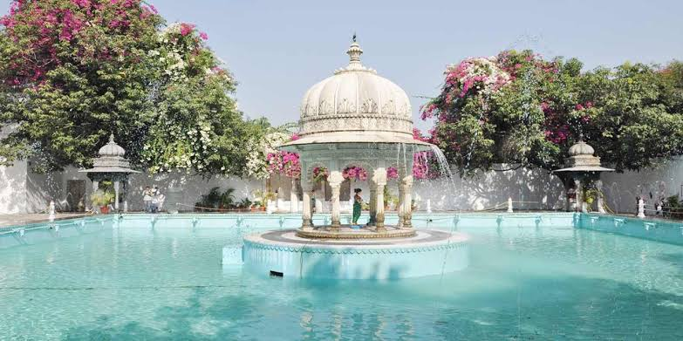
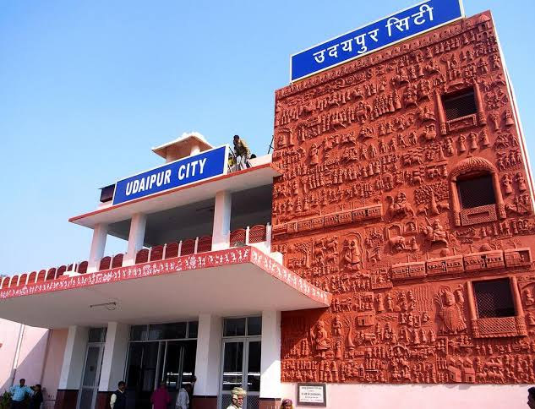
DAY 02 UDAIPUR: (Saturday 8th February, 2020 )

Morning . Reach Udaipur station and board buses for hotel. Freshen up, have breakfast and leave for City Palace Back to Hotel check- in have Lunch Evening leave for Saheliyon-ki-Bari, followed by shopping Back to hotel. Dinner and over night in hotel.

DAY 03 UDAIPUR -CHITTORGARH: (Sunday 9th February, 2020)

Morning after breakfast leave for a visit to Chittaurgarh Fort Enroute lunch will be served. Post lunch return to Udaipur to visit the Fateh Sagar Lake. Back to hotel late evening followed by dinner and overnight at the hotel.

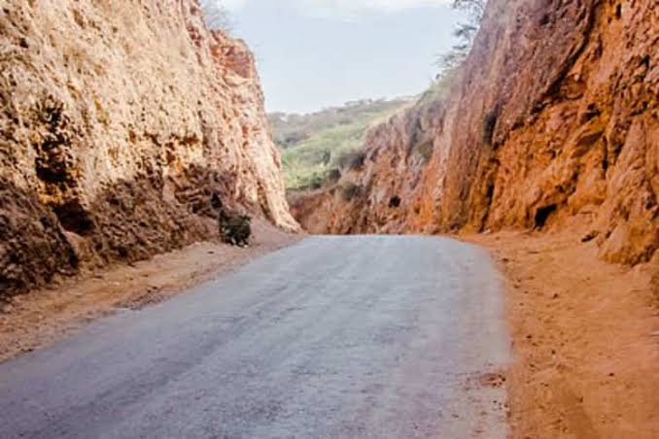
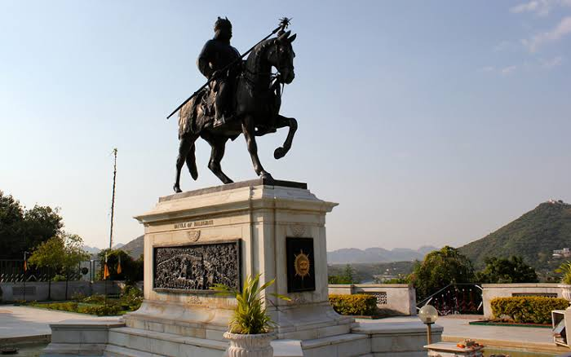
DAY 04 UDAIPUR: (Monday 10th February, 2020)

Morning after breakfast leave for visit to Maharana Pratap Smarak and return for Lunch. After lunch leave for Haldighati, after sightseeing evening board the buses for station to Board the train for Mumbai. Dinner & overnight in train.

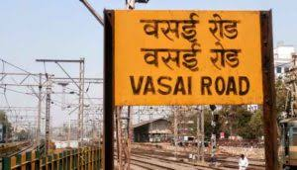
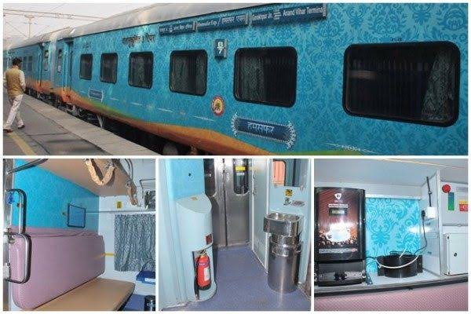
DAY 05 MUMBAI: (Tuesday 11th February, 2020)

Morning breakfast & Lunch will be served in train. Reach Vasai Road Station at 01.05 pm & board the buses for School & Reach School by 04.00 pm depart home with sweet memories.

