Semester II

Subject: ICT Grade: KS2
Name ______________________ Marks: 60
Roll no-_____________________

Q1.Printsyour name, skips the next line, and then prints your address.
Use multiple PRINT commands to print your street address and your city.
Run it. 10.
Q2.Find out the output of the following programs: 10.
CLS
PRINT”HI FRIENDS”
PRINT
PRINT”QBASIC IS AN INTRESTING LANGUAGE”
PRINT
PRINT”TRY OUT YOURSELF”
Q3.Write a program for the following: 10.
Accept the name of two friends in the variables and display a welcome message as shown here.
“HI”<name1>”and”<name2>
“Welcome to my party”

Q4.Design an excel sheet as given below calculate: 10.
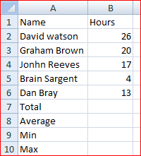
1. The total number of hours worked by all of these five people.
2. The average number of hours worked per person.
3. The maximum number of hours worked by any of these five people.
4. The minimum number of hours worked by any of these five people.
Q5. Choose two numbers, place these in cells B1 and B2 calculate in cell: 10.
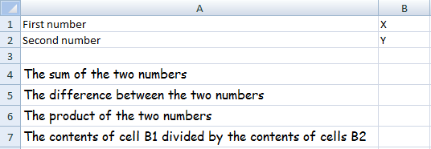
1. B4, the sum of the two numbers
2. B5, the difference between the two numbers
3. B6, the product of the two numbers
4. B7, the contents of cell B1 divided by the contents of cells B2
Q6. 1. Create your presentation on ‘My Class’. 10.
2. The presentation should have slides on class teacher, class location in the school premises, subjects taught and subject teachers ‘details.
3. Give transition effects and animations in your slides.
4. Insert pictures and clip art wherever required.

